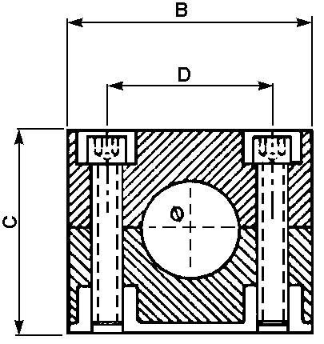

Print
ITEM CODE | DIAMETER MM | D SIZE MM | B SIZE MM | C SIZE MM
02413 | 6 | 20 | 37 | 28
02414 | 8 | 20 | 37 | 28
02546 | 10 | 20 | 37 | 28
02529 | 12 | 20 | 37 | 28
02411 | 14 | 26 | 43 | 33
02547 | 15 | 26 | 43 | 33
02530 | 16 | 26 | 43 | 33
02548 | 18 | 26 | 43 | 33
02549 | 20 | 33 | 50 | 36
02531 | 22 | 33 | 50 | 36
02550 | 25 | 33 | 50 | 36
02532 | 28 | 40 | 57 | 44

